**Login Use Case Diagram**

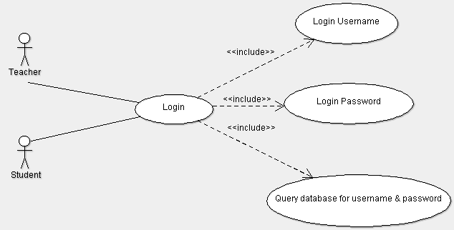

**Brief Description**

The *login* use case enables the student and teacher users to access the Learning Management System by authenticating their input login username and password.

**Step-by-Step Description**

1. Get username and password from respective textboxes on login page.
2. Query both credentials to identify if user is authorized to access system.
3. If authorized, redirect to either student or teachers view, based on role.
4. Otherwise, keep at login page.